

**OOPS**

**WEEK-5**

**NAME** :S. DILIP REDDY **ROLL.NO** : 22R21A05C2 **SECTION** : CSE-B

# PROBLEM STATEMENT:

3.Write a Java Program that creates a Thread by implementing Runnable

interface. The MainThread prints "Hello" for every 1 second and ChildThread should print "your name" twice in 1 second for 10 times.

# CODE:

class Child implements Runnable

{

public void run()

{

System.out.println(Thread.currentThread().getName());

}

}

class Demo8 implements Runnable

{

public static void main(String[] args) throws InterruptedException

{

for(int i=0;i<10;i++)

{

Child c=new Child();

Demo8 d=new Demo8();

Thread t1=new Thread(c);

t1.setName("Ram");

Thread t2=new Thread(d);

t2.start();

t2.join();

t1.start();

Thread.sleep(500);

}

}

public void run()

{

System.out.print("Hello"+" ");

}

}

**Output:**

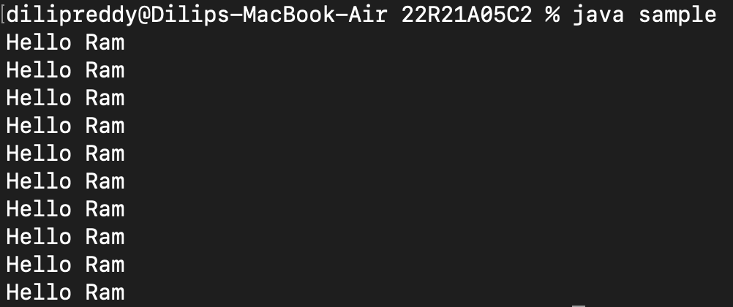

# PROBLEM STATEMENT:

1. Write a C program that uses functions to perform the following:

1. Create a Circular double linked list of integers.

2. Search the nodes in Circular linked list

3. Find the length of the Circular linked list

# CODE:

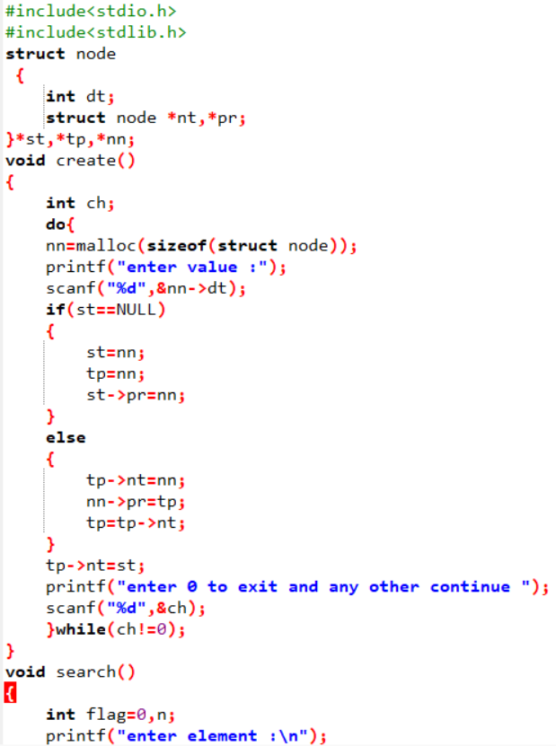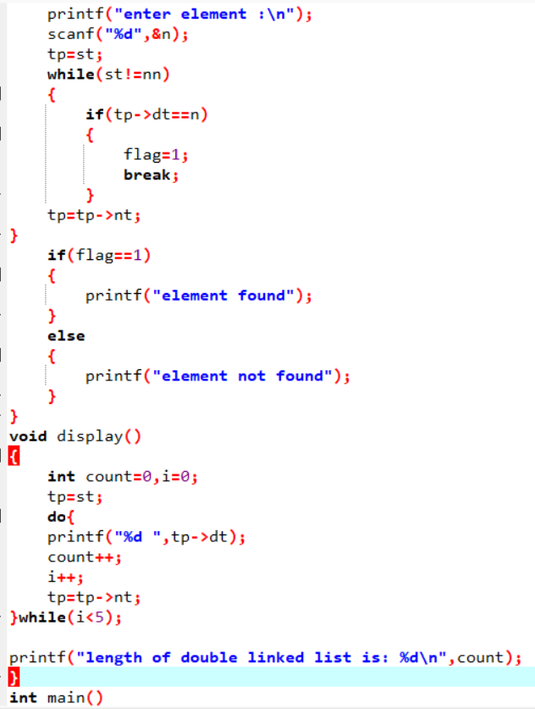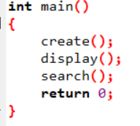

**Output:**

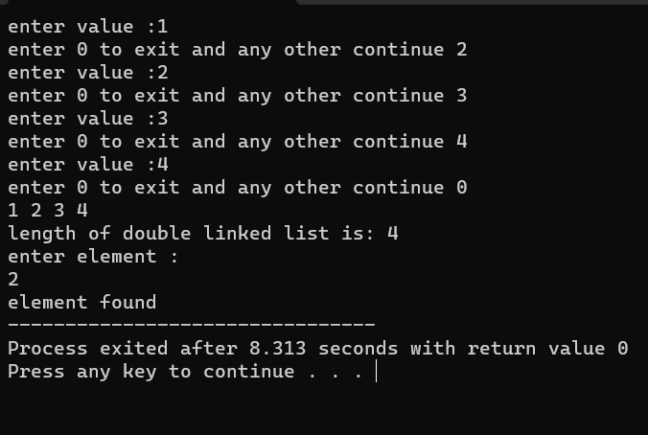

# PROBLEM STATEMENT:

1. Write a C program that uses functions to perform the following:

a. Create a Single linked list of integers.

b. Display the Nodes

c. Delete a node at Beginning and after

# CODE:

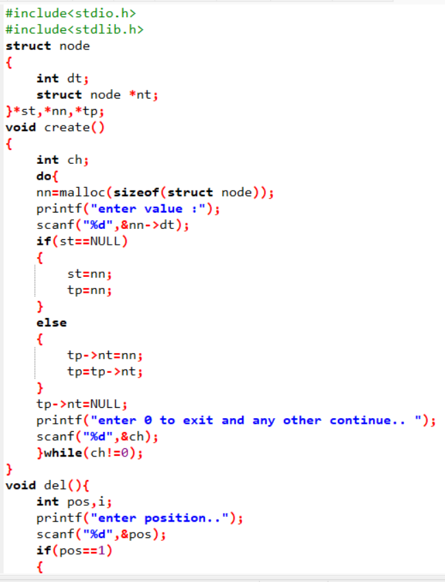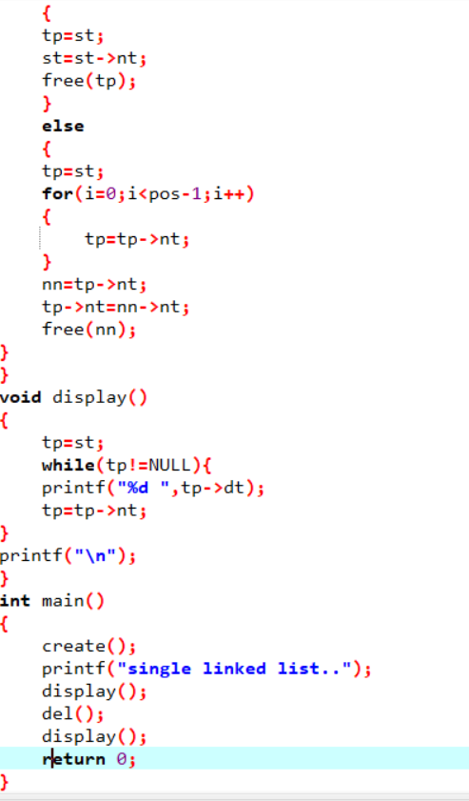

**Output:**

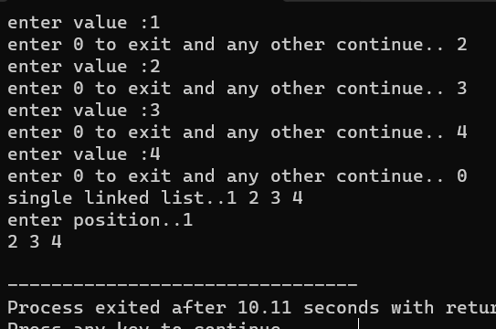

# PROBLEM STATEMENT:

1. Write a C program that uses functions to perform the following:

a. Create a Double linked list of integers.

b. Insert Element at begin, Last, At a Position

c. Display the contents of the above list

# CODE:

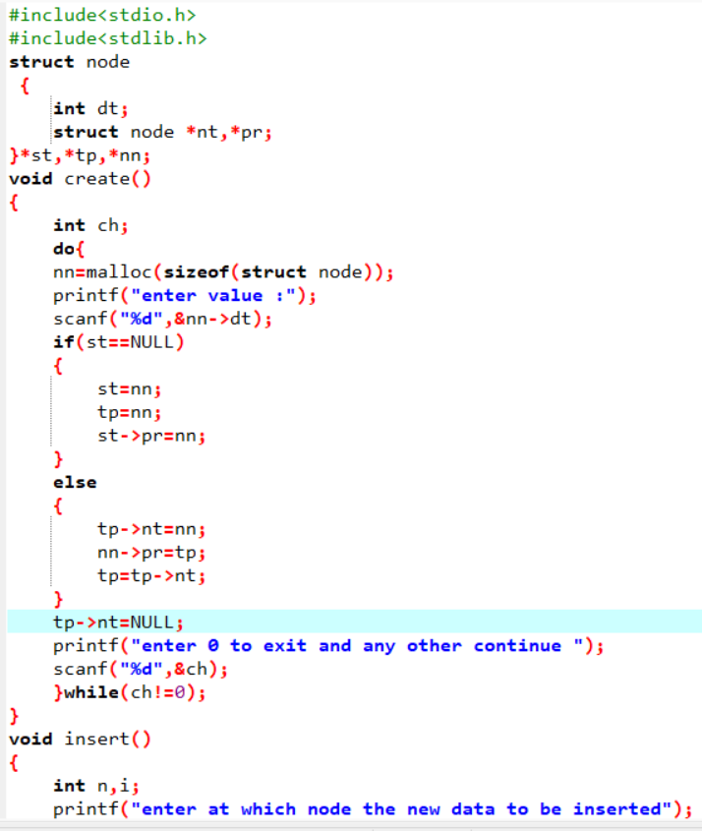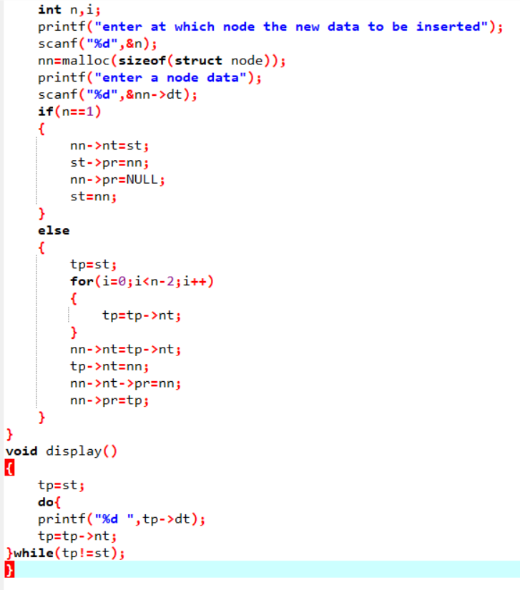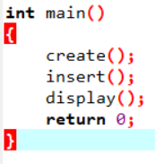

**Output :**

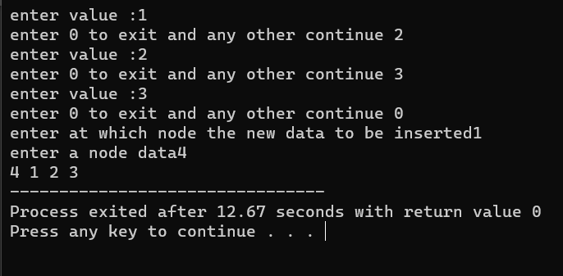

# PROBLEM STATEMENT:

1. Write a C program that uses functions to perform the following:

a. Create a double linked list of integers.

b. Search the nodes in List

c. Find the length of the Double linked list

# CODE:

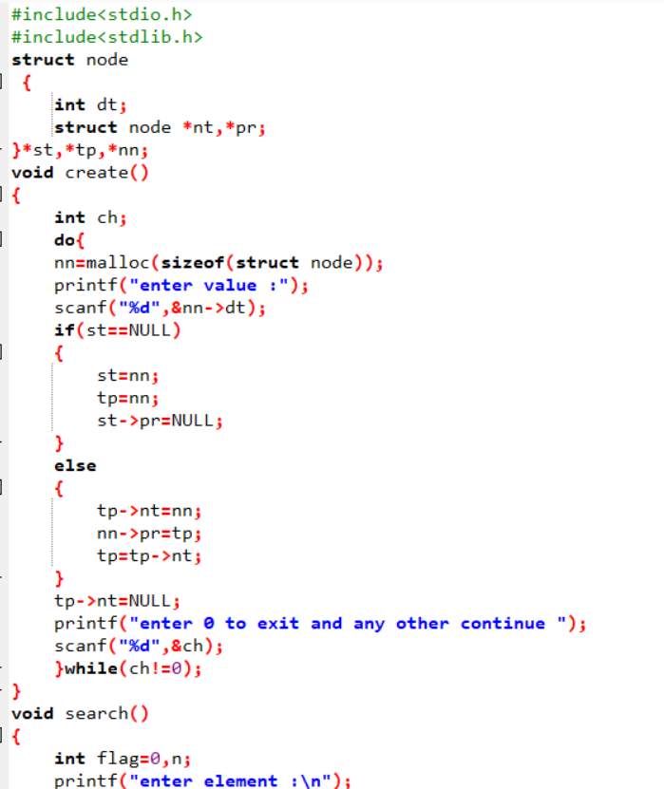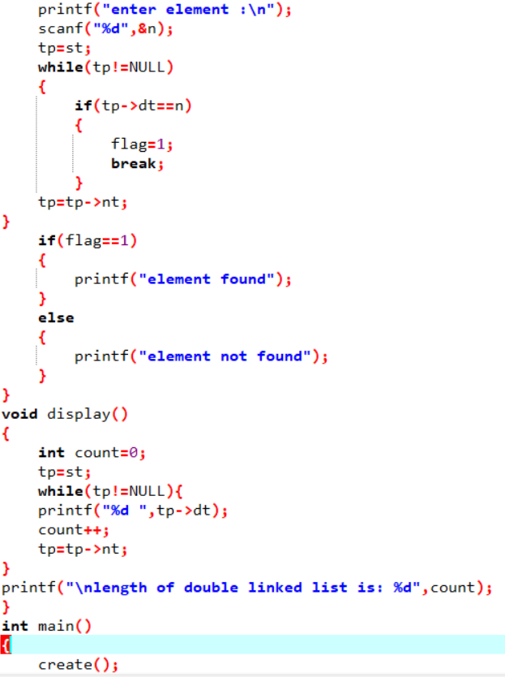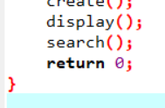

**Output :**

